COLLEKT - 2-YEAR FINANCIAL MODEL

Core Financial Assumptions

Metric | Year 1 - Months 1-12 | Year 2 - Months 13-24
Beta / Free Period | Months 1-3 | -
Professional Subscription | $15/month | $15/month
Company Subscription | $50/month | $50/month
Minimum Project Value | ₦600,000 | ₦600,000
Collekt Commission | 10% | 10%
Commission at Minimum Project Value | ₦60,000/project | ₦60,000/project
FX Benchmark | $1 = ₦1,500 | $1 = ₦1,500

Business Model
Collekt generates revenue from two complementary streams:
- Recurring subscriptions
  - Professionals: $15/month
  - Companies: $50/month
- Transaction commissions
  - 10% commission on completed projects
  - Minimum project value: ₦600,000
  - Minimum Collekt commission: ₦60,000 per completed project
The first three months operate as a free/beta phase to build marketplace liquidity before monetization begins in Month 4.

2. Year 1 — Market Entry & Monetization
Growth Strategy
PHASE | MONTHS | PROFESSIONALS | COMPANIES | PROJECTS / MONTH
Beta / Onboarding | M1–M3 | Free | Free | 0
Revenue Launch | M4–M6 | ~40 | ~20 | ~20-22
Expansion | M7–M9 | ~80 | ~40 | ~30
Maturity | M10–M12 | ~125-150 | ~65-80 | ~43-50

The objective in Year 1 is to establish marketplace liquidity, prove willingness to pay, and demonstrate repeatable transaction activity.

Year 1 Quarterly Revenue
Revenue Stream | Q1 M1-M3 | Q2 M4-M6 | Q3 M7-M9 | Q4 M10-M12 | Year 1
Professional Subscriptions | $0 | $600 | $1,200 | $2,250 | $4,050
Company Subscriptions | $0 | $1,000 | $2,000 | $4,000 | $7,000
Subscription Revenue | $0 | $1,600 | $3,200 | $6,250 | $11,050
Completed Projects | 0 | 65 | 90 | 130 | 285
Commission Revenue | ₦0 | ₦3.90M | ₦5.40M | ₦7.80M | ₦17.10M
Commission Revenue - USD | $0 | $2,600 | $3,600 | $5,200 | $11,400
Total Revenue - USD Equivalent | $0 | $4,200 | $6,800 | $11,450 | $22,450

Year 1 Revenue Mix
Total Year 1 Revenue: approximately $22,450
- Subscription revenue: $11,050
- Transaction commission: $11,400
- Subscription contribution: ~49%
- Transaction contribution: ~51%
This gives Collekt a healthy combination of predictable recurring revenue + transaction-based upside.
Year 1 Exit Run Rate
By Month 12, the target is approximately:
- 150 paid professionals → $2,250/month
- 80 paying companies → $4,000/month
- 50 completed projects/month → ₦3.0M/month → ~$2,000/month→~$24,000
Target Month 12 MRR: ~$75,000
Annualized Revenue Run Rate: ~$99,400

3. Year 2 - Scale & Network Effects
Year 2 shifts Collekt from initial market validation into marketplace expansion and transaction scaling.
The primary growth drivers are:
- Larger professional network
- Increasing number of paying companies
- Higher project liquidity
- Repeat transactions
- Expansion beyond the initial Nigerian market
- Increasing transaction frequency per company

3.1 Year 2 - Market Entry & Monetization
Growth Strategy

PHASE | MONTHS | PROFESSIONALS | COMPANIES | PROJECTS / MONTH
Upscaling | M13–M15 | 185 | 95 | 60
Revenue Launch | M16–M18 | 260 | 130 | 75
Expansion | M19–M21 | 350 | 175 | 97
Maturity | M22–M24 | 450 | 250 | 140

Year 2 Quarterly Revenue
Revenue Stream | Q5 M13-15 | Q6 M16-18 | Q7 M19-21 | Q8 M22-24 | Year 2
Professional Subscriptions | $2,775 | $3,900 | $5,250 | $6,750 | $18,675
Company Subscriptions | $4,750 | $6,500 | $8,750 | $12,500 | $32,500
Subscription Revenue | $7,525 | $10,400 | $14,000 | $19,250 | $51,175
Completed Projects | 175 | 225 | 290 | 375 | 1,065
Commission Revenue | ₦10.50M | ₦13.50M | ₦17.40M | ₦22.50M | ₦63.90M
Commission Revenue - USD | $7,000 | $9,000 | $11,600 | $15,000 | $42,600
Total Revenue - USD Equivalent | $14,525 | $19,400 | $25,600 | $34,250 | $93,775

4. Year 2 Exit Run Rate
By Month 24, the target is:
- 500 paid professionals → $7,500/month
- 250 paying companies → $12,500/month
- 140 completed projects/month → ₦8.4M/month → ~$5,600/month→ ~$67,200
Target Month 24 MRR
~$20,000/month
Annualized Revenue Run Rate
~$307,200/year
This is an important investor metric because it demonstrates that while cumulative revenue is still relatively modest, the business is exiting Year 2 at a materially higher revenue velocity.

5. Two-Year Financial Summary
Financial Benchmark | Year 1 | Year 2 | 2-Year Total
Exit Paid Professionals | 150 | 500 | 500
Exit Paid Companies | 80 | 250 | 250
Completed Projects | 285 | 1,065 | 1,350
Subscription Revenue | $22,450 | $93,775 | $116,225
Commission Revenue | ₦17.10M | ₦63.90M | ₦81.00M
Commission Revenue - USD | $11,400 | $42,600 | $54,000
Total Revenue - USD Equivalent | $33,850 | $136,375 | $170,225
Exit MRR | ~$2,000 | ~$5,600 | ~$5,600
Exit Annualized Run Rate | ~$99,400 | ~$307,200 | ~$307,200

2-Year Base Case
Cumulative revenue: ~$307,200
Cumulative completed projects: 1,350
Year 2 exit MRR: ~$5,600
Year 2 exit annualized revenue run rate: ~$307,200

6. Upside Scenario - Higher Average Project Values
The ₦600,000 project value should be treated as the floor, not necessarily the expected average transaction value.
For Collekt's target market oil & gas, engineering, EPC, procurement, consulting and infrastructure, the average project value could reasonably be higher as the marketplace matures.
Scenario Analysis
Average Project Value | Collekt Commission | Year 1 Commission | Year 2 Commission | 2-Year Commission
₦600K - Base | ₦60K | ₦17.10M | ₦63.90M | ₦81.00M
₦1.5M - Upside | ₦150K | ₦42.75M | ₦159.75M | ₦202.50M
₦3.0M - High Upside | ₦300K | ₦85.50M | ₦319.50M | ₦405.00M

At the ₦1.5M average project value, transaction commission alone becomes:
- Year 1: $28,500
- Year 2: $106,500
- Two-year commission: $135,000
Adding subscription revenue:
2-Year Revenue ≈ $302,200

At a ₦3M average project value:
2-Year Revenue ≈ $437,200

7. Collekt's Revenue Model at a Glance
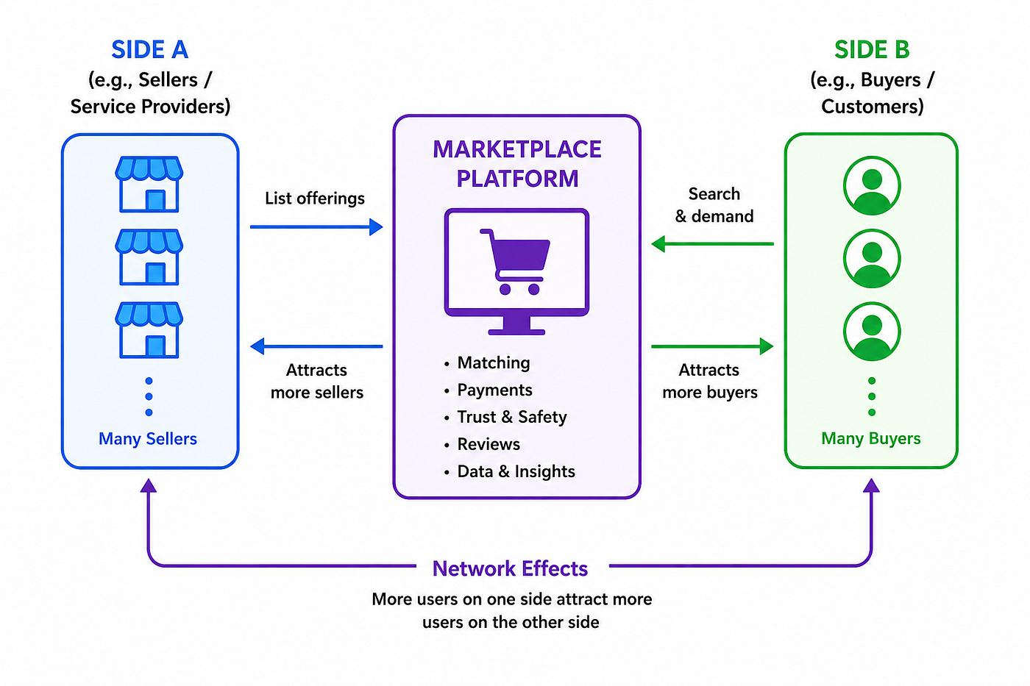

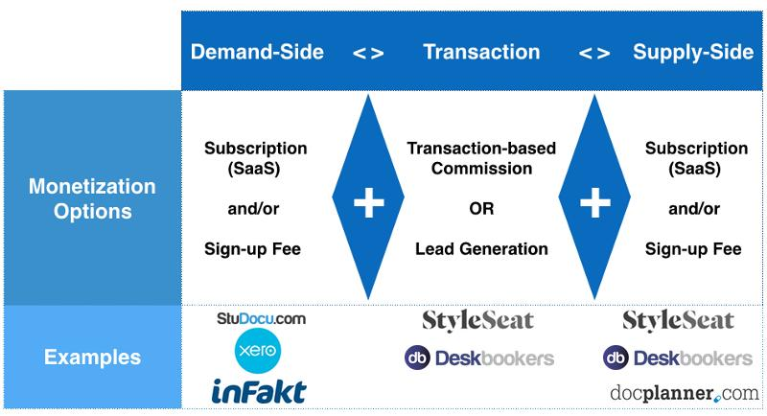

Base Case
Users → Subscriptions → Projects → Transactions → Commission
Collekt therefore has three key economic levers:
1. User Growth
More professionals and companies create a larger addressable marketplace.
2. Subscription Conversion
As the platform moves beyond beta, free users convert into recurring paid accounts.
3. Transaction Volume & Value
Higher project frequency and higher average project values directly increase Collekt's take rate revenue.
This creates an attractive flywheel:
More Professionals → More Capability → More Companies → More Projects → More Revenue → More Professionals & Companies

Important Milestones
1 Contract
5 Contracts
10 Contracts
100 Contracts
500 Contracts
1,000 Contracts
5,000 Contracts
10,000 Contracts
50,000 Contracts

